# Ideation Phase

|  |  |
| --- | --- |
| Date | 22 September 2022 |
| Team ID | PNT2022TMID25247 |
| Project Name | AI based discourse for Banking Industry |

**Brainstorming Ideation:**

Frequently asked question to store in database and counting update to add the queries corresponding answer. If customer asked frequently question can be find and to feed in the database after include a voice in chatbot.

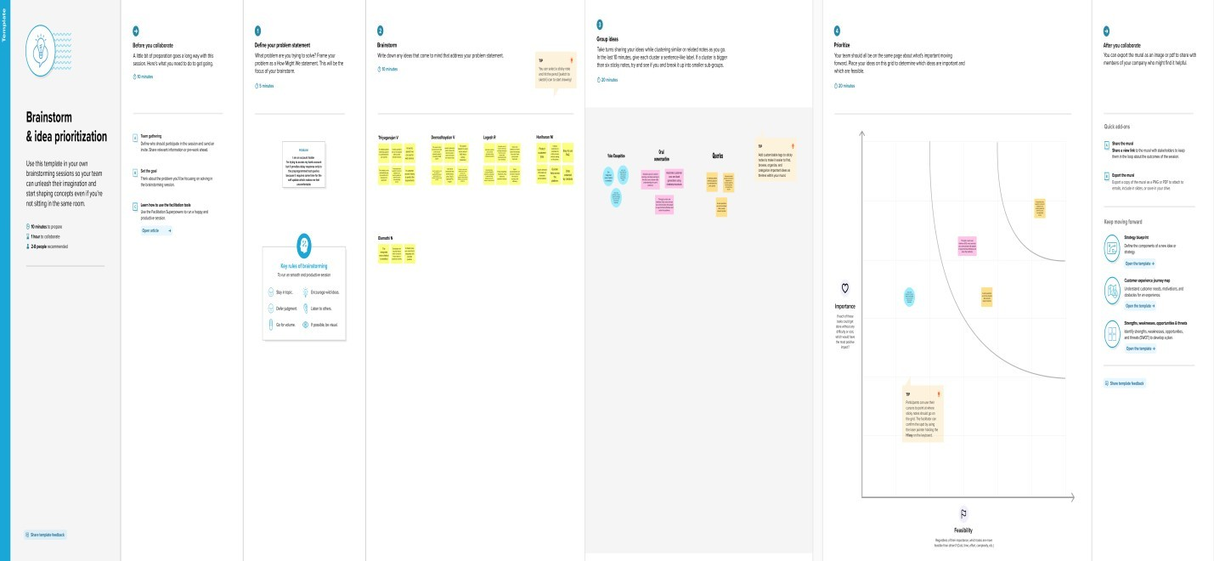

# Brainstorm Ideation:

https://app.mural.co/invitation/mural/aichatbotforbankingindustry3733/166142019 3240?sender=u18601c8be4ea48569db74064&key=23c9dae4-e287-4839-a50b- b7f890920bf5